Purpose : This Doc describes the Use Case Diagram of the ADMIN module and brief description of functionalities of the admin.

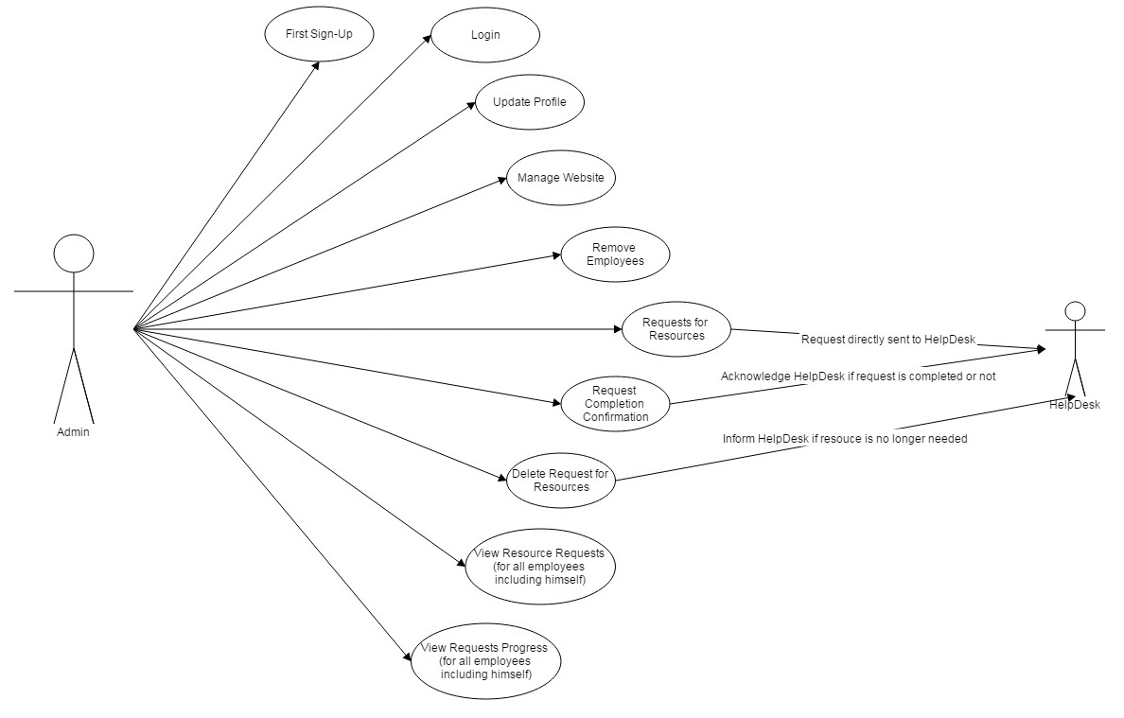

2. ADMIN --

    - Sign-Up :
The First sign-up module for admin.

    - Login :
Module to login for Admin.

    - Update Profile :
Admin should be able to modify its own profile such as change of contact number, change of profile picture, etc.

    - Manage Website :
Admin should have all the access of the website so that admin can do all the necessary changes required to maintain the website.

    - Remove Employees :
Admin can remove the employees in case the employee leaves the organization.

    - Requests for Resources :
Admin can request for any resource required to him and the request is directly forwarded to the Help desk.

    - Request Completion Confirmation :
The confirmation is sent to the Help desk regarding the completion of the request in order to cross check.

    - Delete Request for resouces :
Admin can delete his/her resource request if the resource is no longer needed to him/her and acknowledge the Help desk regarding the same.

    - View Resource Requests :
Admin can view the list of resources asked by him/her and resources asked by the employees along with the name of the employees who have requested the resources and the approval status of the request given by Heads.

    - View Requests Progress :
Admin can also view the current status of the approved requests to ensure the delivery of the resource for everyone.

